Assessment task — Australia in the past: Sources

Australia in the past
Source 1
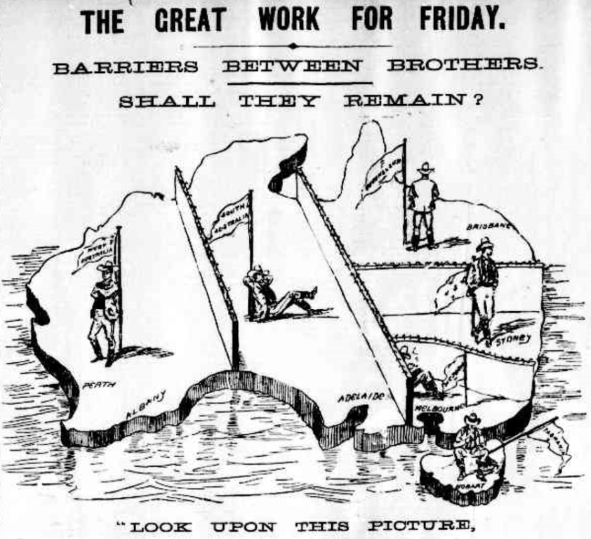
‘The great work for Friday’ in The Argus (Melbourne), 1 June 1898, p.5, http://trove.nla.gov.au/ndp/del/page/310001
Source 2
House of Commons
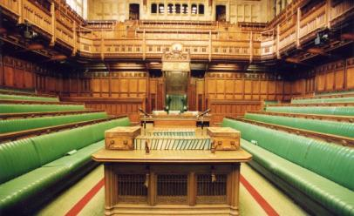
UK Parliament, House of Commons Chamber: Speaker’s table, https://www.flickr.com/photos/uk_parliament/2700549757/ CC BY-NC-ND 2.0 creativecommons.org/licenses/by-nc-nd/2.0/
Source 3
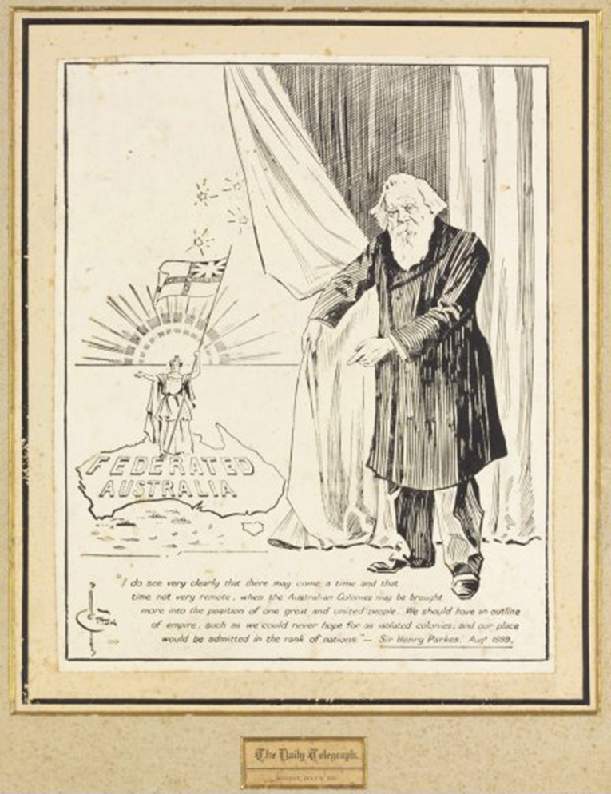
Image — Cotton, H., ‘Federated Australia’ drawing, Daily Telegraph, Sydney, 1900,
(TLF R8045) National Library of Australia, National Library of Australia number nla.pic-an6222063
Context for Source 3: This is a black-and-white pen-and-ink drawing by cartoonist and illustrator Herbert Cotton from 1900, of the New South Wales politician, Sir Henry Parkes, which appeared in the Daily Telegraph. Beneath the drawing is a quote from Parkes in which he speaks of a vision for a federation of the Australian colonies.
‘I do see very clearly that there may come a time and that time not very remote, when the Australian Colonies may be brought more into the position of one great and united people. We should have an outline of empire, such as we could never hope for as isolated colonies, and our place would be admitted in the rank of nations.’ — Sir Henry Parkes. August 1889
Text — Sir Henry Parkes, August 1889; Transcript of the quotation at the bottom of the drawing. (TLF R8045)

